*ELEKTRA Develops LED Ring Light*  
**Technology Meets Design, Installation Meets Sustainability**

**A LED ring light that looks good, is easy to install, and provides strong illumination? With the LD 8228, ELEKTRA brings a minimalist solution to the market that meets the high demands of the kitchen & furniture industries and of retailers.**

“These days, with tougher competition and the loss of purchasing power, visually appealing and easy-to-install lighting systems make a real difference,” explains ELEKTRA Managing Director Boris Niessing. For this reason, the LED experts from Enger, North Rhine-Westphalia, combined high-quality technology with a sophisticated design in the new LD 8228 surface-mounted light. The result is a glare-free and powerful low-profile light in a smart ring shape – but both installers and retail customers are also impressed by the light’s other plus points, such as easy installation and reduced process costs.

**Simple Installation – Less Material Needed**  
“Until now, users installing ring lights had to mill or screw into the wood and drill holes for the wiring,” says Henrik Bültmann, the Head of Development and Construction at ELEKTRA responsible for product development and technology. “We wanted to optimize this process for the customer, so we designed a self-adhesive solution with a flat cable connection.” The light and the cable can be easily mounted, retrofitted, and removed without leaving any residue. Furniture remains undamaged during both installation and later removal. Bültmann is particularly proud of the flat cable electrification: “Our solution is based on a LED tape. It makes handling much easier for the customer and significantly reduces the effort involved in installation.” Thanks to its minimal height, the cable is almost invisible. It is available in white or black.

Less can mean more! During the production of the ring light, the LED specialists combined efficiency with sustainability. They produce the COB (Chip on Board) LEDs as ring segments with four pieces per light, ensuring the most efficient “less-waste” approach possible. This intelligent planning was rewarded with the Interzum Award 2023 in the sustainability category – since conventional spotlights with a diameter of 78 millimeters require twice as much material.

**Creative Partner**

ELEKTRA focuses on discreet electrification and sustainable, innovative light design. “Our goal is to be a development partner for the industry,” explains Bültmann. “That’s why we developed a completely different approach to manufacturing the conventional recessed light.” This creative effort has also paid off – for example, ELEKTRA came up with the idea of angling the cover of the ring light inward to achieve glare-free illumination.

The LD 8228 operates at 24 volts and is available with different dimmable light colors ranging from 2,700 to 6,400 Kelvin MIX, 3,000 and 4,000 Kelvin. The configurable connection is also flexible, since various plug connections can be soldered onto the FlexPCBs. “Our products are all 'Designed and Engineered in Germany' – and we test each lighting product groups individually in our Light Test Center,” says Boris Niessing. Most of the ELEKTRA systems are UL-certified, making them suitable for the American market. “In the US, it is mainly kitchen and home furniture manufacturers who are really interested in our smart lighting solutions,” adds the Managing Director.

*3,415 characters incl. spaces*

**Service for editors**

***Meta title:*** *ELEKTRA presents a sustainable and easy-to-install LED ring light*

***Meta description:*** *Design meets technology! ELEKTRA develops sophisticated lighting systems, the aesthetics, functionality, and sustainability of which are extremely convincing.*

***Social media post:***

*ELEKTRA develops custom lighting systems for kitchens and furniture. The focus is on design-oriented, stylish and bright LED lights that combine cutting-edge technology with a highly appealing look. The LD 8228 surface-mounted light with its minimalist design and smart ring shape is just one highlight of these systems. It provides glare-free and powerful lighting, and the designers also placed great emphasis on efficiency and sustainability during production.*

**Captions:**

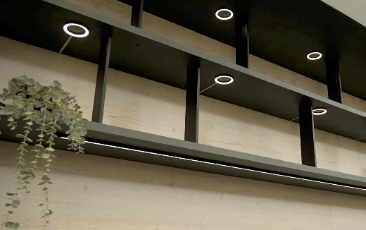

**Photo 01**: Sophisticated and powerful LED lighting systems are in great demand – and the smart ring shape of the LD 8228 from ELEKTRA is a real highlight in the kitchen and furniture industry.

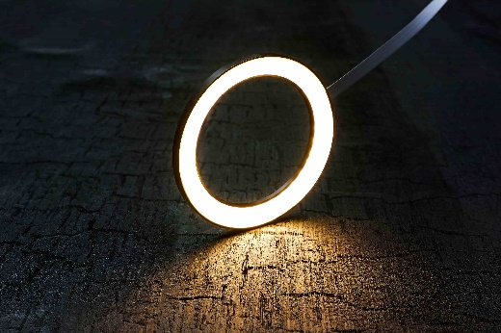

**Photo 02**: The surface-mounted light combines technology and design.

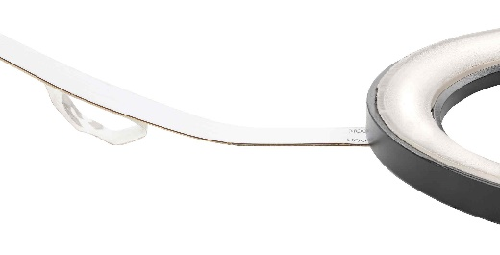

**Photo 03**: The flat cable connection adheres easily to furniture and is almost invisible.

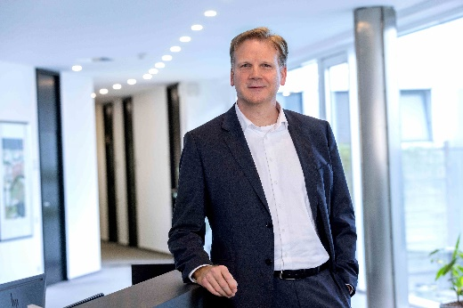

**Photo 04**: Boris Niessing, Managing Director at ELEKTRA, is proud of the lighting systems that are all “Designed and Engineered in Germany.”



**Photo 05**: Henrik Bültmann, Head of Development and Construction at ELEKTRA, designed the LD 8228 ring light.

**Picture credits:** ELEKTRA GmbH

**The high-resolution image material is available** [**here**](https://newcloud.a1kommunikation.de/index.php/s/Tf7c14MkMcIqGiQ) **to download.**

**About the company**

ELEKTRA GmbH, a member of EHLEBRACHT Group, is a leading German manufacturer of technically innovative, highly functional lighting systems and a system supplier for plastics and electrical engineering in the furniture, kitchen, store outfitting and industry. Alongside the highest product quality, the company also strives for an environmentally friendly approach. ELEKTRA not only focuses on intelligent solutions, but also on increasingly sustainable manufacturing processes. With 1,200 employees worldwide in Germany, USA and China, ELEKTRA supplies its worldwide customers with ready-to-connect lights and lighting systems as well as products for OEM partners. For more information, see: [www.elektra.de/en](http://www.elektra.de/en/)

**ELEKTRA Gesellschaft für elektrotechnische Geräte mbH**

a company of EHLEBRACHT Holding AG

Werkstrasse 7

32130 Enger  
[www.elektra.de/en](http://www.elektra.de/en/)

**[Square LinkedIn logo, isolated on white background...](https://www.linkedin.com/company/elektra-gmbh/)**

**Press contact at ELEKTRA GmbH**

Nadine Stückmann, Head of Marketing

Tel.: +49 5223 185-362

[n.stueckmann@elektra.de](mailto:n.stueckmann@elektra.de)

Birgitt Vogt

Tel. +49 (0) 5223 185 363

[b.vogt@elektra.de](mailto:b.vogt@elektra.de)