*ELEKTRA: A leading developer and manufacturer of lighting systems*

**Made in Enger**

**ELEKTRA GmbH, based in Enger in the German state of North Rhine–Westphalia, is known for lights and lighting systems of the highest quality. Its intelligent, sustainable products, made in Germany, have been on the market since 1979. With its expertise in development and manufacturing, the company regularly sets new benchmarks in the market and offers individual solutions as an OEM partner. Customers throughout the world, including manufacturers of furniture, kitchen fittings and store fittings, benefit from its innovative products.**

The products of ELEKTRA GmbH stand out for sophisticated engineering, excellent quality, minimalistic design and maximum safety. The company manufactures LED-based linear lights, spotlights, conductor profiles, lamp drivers and connector systems in its leading-edge production facility in China and Enger, North Rhine–Westphalia. The growing product range also includes smart lights, which are controlled by intelligent systems. ELEKTRA’s specialists are continuously setting new trends when it comes to luminous flux, service life, color rendering index and color control.

The company has customers in more than 30 countries, including makers of furniture, kitchen fittings and store fittings, plus other manufacturing companies. It also offers in-depth advice and reliable service. The team optimizes its processes for customers, making assembly and later disassembly as simple as possible. Another point in its favor is sustainability. ELEKTRA is known for efficient production processes and reduced use of materials.

**Working together to find solutions**

The development department at ELEKTRA specializes in OEM projects, where the goal is to work out customized, flexible solutions for manufacturers. Here the company sees itself as a sparring partner: A suitable lighting system is developed in close cooperation with the customer in a team, beginning with an idea and a drawing, moving ahead to tool production and prototyping, and culminating in delivery of the final product.

One example of a successful OEM project is the cooperative relationship with Sauder Closets, in which ELEKTRA supplies sophisticated lighting systems.

**From Enger to Wilmington**

Established in 1979, ELEKTRA is now part of the global EHLEBRACHT Group. The company’s small team began making products for OEMs after only a year, and its business with renowned customers laid the foundation for a promising business model. Numerous groundbreaking products followed: a round, compact fluorescent lamp with an exchangeable tube, innovative illuminated shelves, powerful chip-on-board LEDs and radial LEDs made a big impression on the market.

The company now has 1,200 employees in two branch operations. Approximately 100 persons are at work in Enger in development, production and quality control. In China, the wholly owned subsidiary ELEKTRA Industrial China Co., Ltd., has more than 1,100 employees at three locations. Besides being engaged in plastics production and tool development, the teams in China are building tools on state-of-the-art CNC machining centers. They are also assembling plastic and electrotechnical components for sale. In 2024, ELEKTRA opened a new office in Wilmington, North Carolina, USA, where it will respond to strong demand from furniture manufacturers and shopfitters for smart, sustainable lighting solutions. An external warehouse ensures fast deliveries, and retail partners provide reliable service.

**Looking ahead**

“We’re on the right path,” says Boris Niessing, who shares the role of Managing Director at ELEKTRA with Matthias Delius. “We can rely on regular innovations, a stable market in Germany, a successful branch in China and strong partners in the American market. But of course we want to grow, continue our international expansion and become even better known as an innovative, reliable supplier of high-quality lights and lighting systems.”

*3.971 characters incl. spaces*

**Service for editors**

**Meta title:** ELEKTRA: A leading developer and manufacturer of lighting systems

**Meta description:** ELEKTRA manufactures smart lights and lighting systems, with sustainability in mind. The company has a high degree of expertise in development and production.

**Social media posting:** Sustainable, smart lights and lighting systems for makers of furniture, kitchen fittings and store fittings, plus other manufacturing companies: Based in Enger in the German state of North Rhine–Westphalia, ELEKTRA is known for high-quality products, in-depth advice and reliable service. OEM customers benefit from the company’s expertise in development and production.

**Captions:**

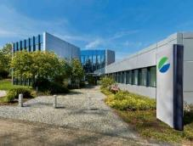

**Photo 01:** Approximately 100 employees are engaged in development, production and quality control at ELEKTRA’s location in Enger in the German state of North Rhine–Westphalia.

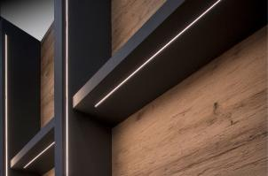

**Photo 02:** The LD8104 is an example of the sleek, elegant design favored by ELEKTRA’s developers.

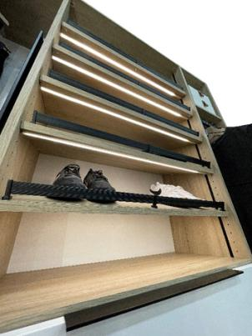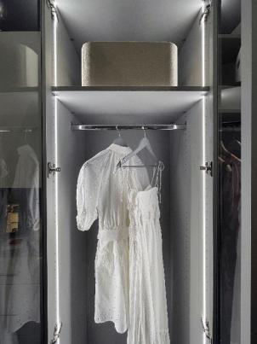

**Photo 03:** Flexible, custom design: The closet and wardrobe are illuminated by a vertical (left) or horizontal (right) LED light strip depending on the application. This shows the versatility of ELEKTRA’s designers for OEM solutions.

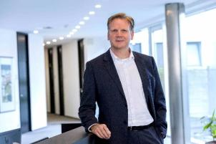

**Photo 04:** ELEKTRA’s Managing Director Boris Niessing: “Our goal is to continue to expand our international sales and become even better known on the market as a developer and manufacturer of high-quality products.”

**Photo credits:** ELEKTRA GmbH

**The high-resolution image material is available [here](https://newcloud.a1kommunikation.de/index.php/s/hpKUyYodIpiQoYS) to download.**

**About the company**

ELEKTRA GmbH, a member of EHLEBRACHT Group, is a leading German manufacturer of technically innovative, highly functional lighting systems and a system supplier for plastics and electrical engineering in the furniture, kitchen, store outfitting and industry. Alongside the highest product quality, the company also strives for an environmentally friendly approach. ELEKTRA not only focuses on intelligent solutions, but also on increasingly sustainable manufacturing processes. With 1,200 employees worldwide in Germany, USA and China, ELEKTRA supplies its worldwide customers with ready-to-connect lights and lighting systems as well as products for OEM partners. For more information, see: [www.elektra.de/en](http://www.elektra.de/en/)

**ELEKTRA Gesellschaft für elektrotechnische Geräte mbH**

a company of EHLEBRACHT Holding AG

Werkstrasse 7

32130 Enger  
[www.elektra.de/en](http://www.elektra.de/en/)

**[Square LinkedIn logo, isolated on white background...](https://www.linkedin.com/company/elektra-gmbh/)**

**Press contact at ELEKTRA GmbH**

Nadine Stückmann, Head of Marketing

Tel.: +49 5223 185-362

[n.stueckmann@elektra.de](mailto:n.stueckmann@elektra.de)

Birgitt Vogt

Tel. +49 (0) 5223 185 363

[b.vogt@elektra.de](mailto:b.vogt@elektra.de)