ELEKTRA – the specialist for glare-free ambient lighting
Visual enhancement for niches

How can a complete rear wall in the kitchen or living area be illuminated simply but filigree? ELEKTRA has developed a charming idea for this – and the company is well-known for its design-oriented, bright LED systems.

It’s functional, minimalist and an absolute visual highlight for recesses – ELEKTRA has now developed lighting that has never been seen before in this form – the LD8177. The special feature of this extremely filigree lighting system that the customer can easily add additional elements such as shelves or holders. Different versions create an atmospheric ambience that radiates light either upwards, downwards or to the rear, combining the niche and the kitchen furniture into a single unit.

“We wanted to completely rethink niche lighting,” explains Henrik Bültmann, Head of Development and Design at ELEKTRA. “Our aim was to create a high-quality, but very minimalist system, one that wouldn’t be too dominant or overbearing. At the same time, our solution had to provide users with the best possible ambient lighting.” The LD8177 fulfills all these requirements. A strip of small, closely spaced LEDs provides homogeneous, indirect and glare-free lighting. The design concept of the LD8177 fits in visually with all standard furniture grids.

Less can be more
As with all the ELEKTRA solutions, the focus of this new product is on simple installation, which keeps customers’ installation costs low. The furniture manufacturer cuts the panel to size, screws on the light profiles and attaches the complete unit to the wall – done with ease! The cables are routed at the rear. The developers have minimized the range of components and the usage of materials – which means less consumption of resources. ELEKTRA works with just one continuous profile instead of several larger aluminum profiles, saving up to 50 percent material compared to other solutions.

1.957 characters incl. spaces

Service for editors
Meta title: ELEKTRA: filigree niche lighting for the kitchen and living area

Meta description: ELEKTRA enhances niches: A system that’s minimalist and easy to install, the LD8177 enables kitchen and furniture manufacturers to create filigree and atmospheric ambient lighting.

Social media post: Visually enhance niches in kitchens and living areas with the filigree LD8177 LED lighting system from ELEKTRA. During the development of the LD8177, the company focused on simple assembly and reduced resource consumption. The customer can easily add functional elements such as shelves or holders to the system. Various options enable atmospheric light to be emitted either upwards, downwards or backwards.

Photo material:

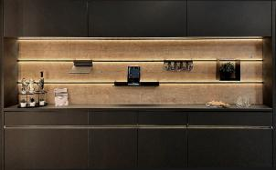

Photo 01: ELEKTRA has succeeded in visually enhancing niches thanks to its atmospheric and glare-free ambient lighting system.

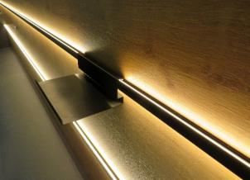

Photo 02: The filigree LD8177 is extremely easy to install.

Photo credits: ELEKTRA GmbH
The high-resolution image material is available here to download.

About the company
ELEKTRA GmbH, a member of EHLEBRACHT Group, is a leading German manufacturer of technically innovative, highly functional lighting systems and a system supplier for plastics and electrical engineering in the furniture, kitchen, store outfitting and industry. Alongside the highest product quality, the company also strives for an environmentally friendly approach. ELEKTRA not only focuses on intelligent solutions, but also on increasingly sustainable manufacturing processes. With 1,200 employees worldwide in Germany, USA and China, ELEKTRA supplies its worldwide customers with ready-to-connect lights and lighting systems as well as products for OEM partners. For more information, see: www.elektra.de/en

ELEKTRA Gesellschaft für elektrotechnische Geräte mbH
a company of EHLEBRACHT Holding AG
Werkstrasse 7
32130 Enger
www.elektra.de/en



Press contact at ELEKTRA GmbH
Nadine Stückmann, Head of Marketing
Tel.: +49 5223 185-362
n.stueckmann@elektra.de

Birgitt Vogt
Tel. +49 (0) 5223 185 363
b.vogt@elektra.de

